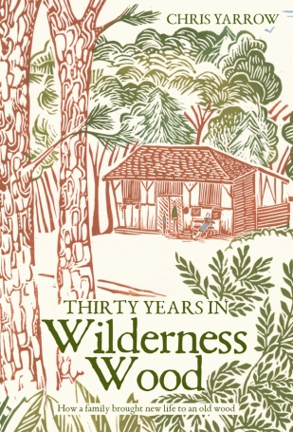
SPECIAL OFFER TO WILDERNESS WOOD VISITORS
Pick up your signed copy of “Thirty Years in Wilderness Wood” for only £15.95 (rrp £16.95) when you visit, or
£17.90 if posted (normally £19.90).
This handsomely-produced hardback book, with many illustrations and colour photos, tells the compelling story behind Wilderness Wood: how Chris and Anne Yarrow and their two young daughters searched for and bought a wood where they could live out their dreams, and transformed a nondescript stretch of Sussex woodland into the much-loved place that you see today.
You’ll read the ups and downs, the fun and the narrow escapes. Read the chapter “Schools, Parties and Events”, how your visit evolved to the great event it now is - it’s a fascinating read for yourself, or a great present.
“Outstanding descriptive writing (with a) rare ability to create a text that takes the reader to the heart of the story” (Mark Pritchard, in Chartered Forester)
“It’s a long time since I’ve enjoyed a book so much. Chris and Anne Yarrow have crafted a masterpiece.” (Prof Julian Evans, OBE)
“Chris Yarrow’s writing is masterful- as witty and full of sideways humor as it is informative.” (Dana Boussard, on publisher’s website)
TO ORDER YOUR SIGNED COPY:
For collection on your visit tick the booking form / email Lucy at lucyslittleforestschool@yahoo.com, adding £15.95 to your booking fee.
To order a copy by post email Chris Yarrow on yarrow@hmill.plus.com, and transfer £17.90 to C and A Yarrow account no 00039976, sort code 30-95-01, using your name as a reference, OR telephone Chris on 01825 831972.

